**Introduction**

**What is Azure Function?**

Azure Functions is a serverless solution that allows you to write less code, maintain less infrastructure, and save on costs. Instead of worrying about deploying and maintaining servers, the cloud infrastructure provides all the up-to-date resources needed to keep your applications running.

Azure Function lets you focus on the pieces of code that matter most to you, and Azure Functions handles the rest.

Azure Functions allows you to implement your system's logic into readily available blocks of code. These code blocks are called "functions". Different functions can run anytime you need to respond to critical events.

**Architecture Diagram**

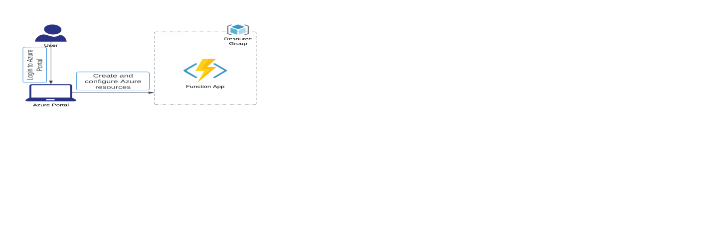

# ****Task Details****

1. Sign in to Azure Portal
2. Create a log analytics workspace
3. Create an Azure Function
4. Browse to Function App
5. Create the HTTP-Triggered Function
6. Test the Azure Function
7. Delete the resources.

# ****Lab Steps****

## ****Task 1: Sign in to Azure Portal****

## ****Task 2: Create a Log Anaytics Workspace****

In this task, we will create a log analytics workspace on Azure Portal.

1. In the search box at the top of the Azure portal, enter Log Analytics Workspace. Select Log analytics from the search results.

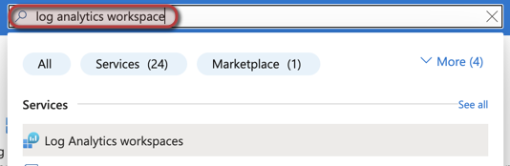

1. In the **Create Log Analytics Workspace**section, enter the following values in the Basics tab.  
   * Resource group : Select **rg_eastus_XXXXX**
     + Instance details :
       - Name : Enter name of your choice
       - Region : Select East US

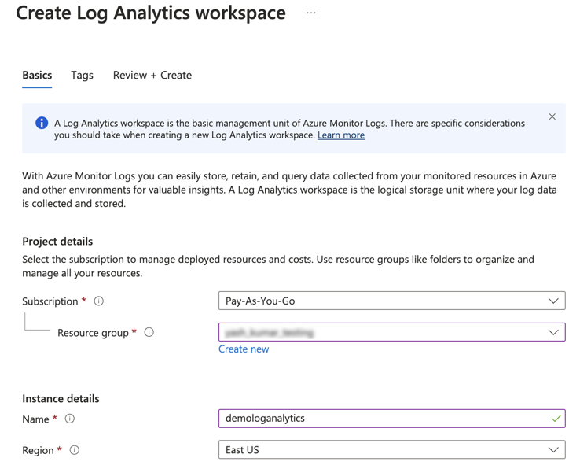

1. Click on **Review + create** and then **Create**.

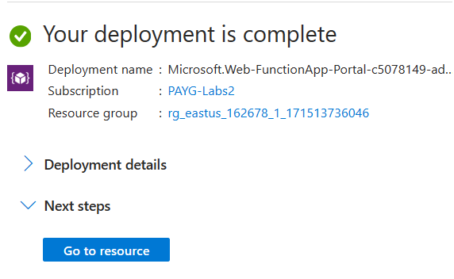

**Task 3: Create an Azure Function**

1. On the Azure portal menu or from the Home page, select **Create a resource**.

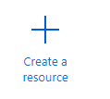

1. In search bar enter ***function app***and click on the Function App option.

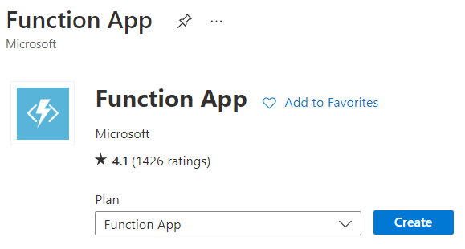

1. On the Function App page click on +**Create** button.

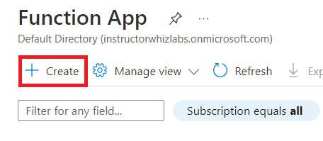

1. On the **Create Function App** page, Select a hosting option as **App Service**.

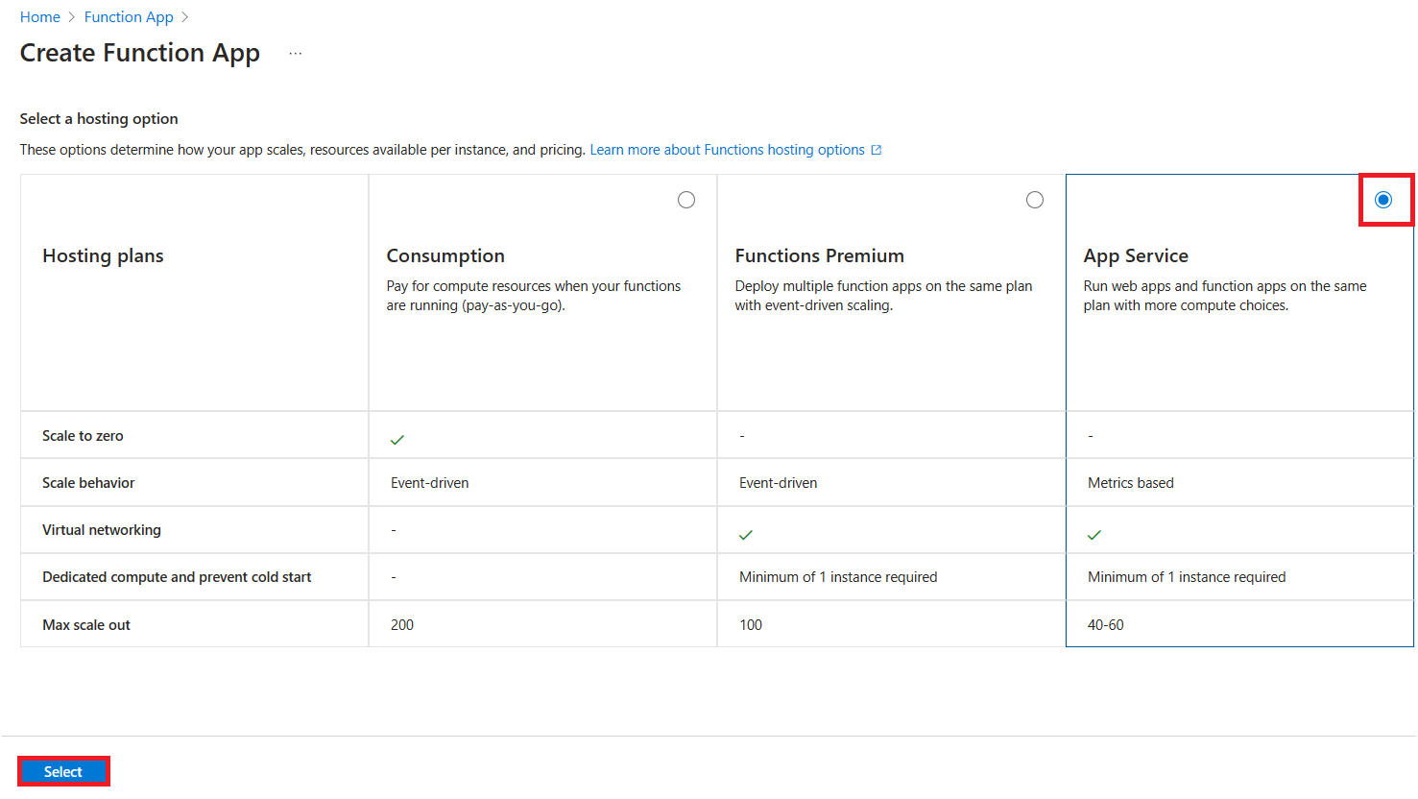

Enter the following information in the basics tab:

* Resource group: Select **rg_eastus_XXXXX**
* Instance Details:
  + Function App name: Enter **WhizlabFunc**

**Note:** Please enter a unique name

* + Publish: Select **Code**
  + Runtime stack: Select **.Net**
  + Version: Select **6 (LTS), in-process model**
  + Region: Select **East US**
* **Note: Kindly select the Runtime stack and Version as mentioned above, otherwise you won't able to create function in azure portal in the next task.**
* Operating System: Select **Windows**
* Leave rest values as default.

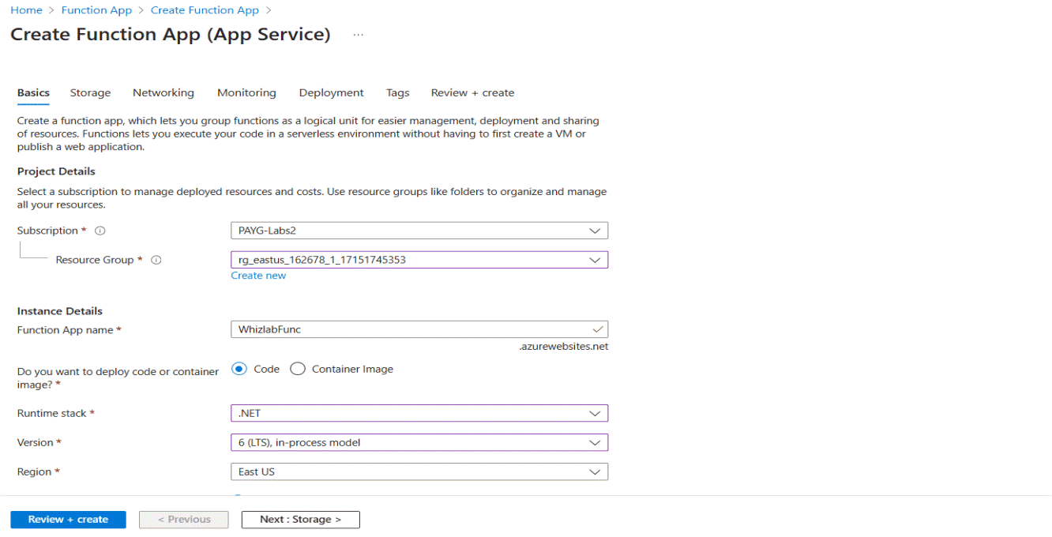

Click on **Review + create** and then select**Create**.

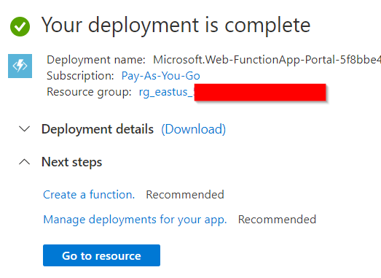

## ****Task 3: Browse to Function App****

1. Once the deployment is complete, click **Go to resource**.
2. Click on the **Browse** button on the top. It will open the the function App in a new tab and we can able to see the function is running.

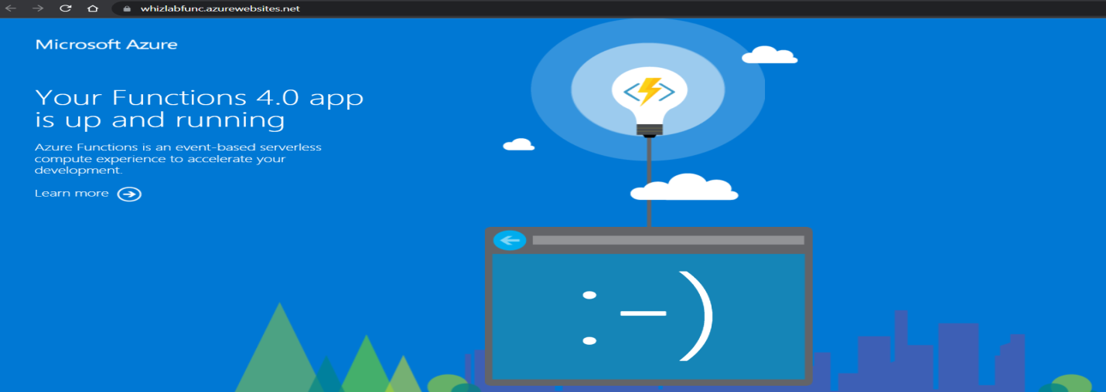

## ****Task 4: Create the HTTP-Triggered Function****

1. Go back to the Function App page and select **create in Azure portal**.

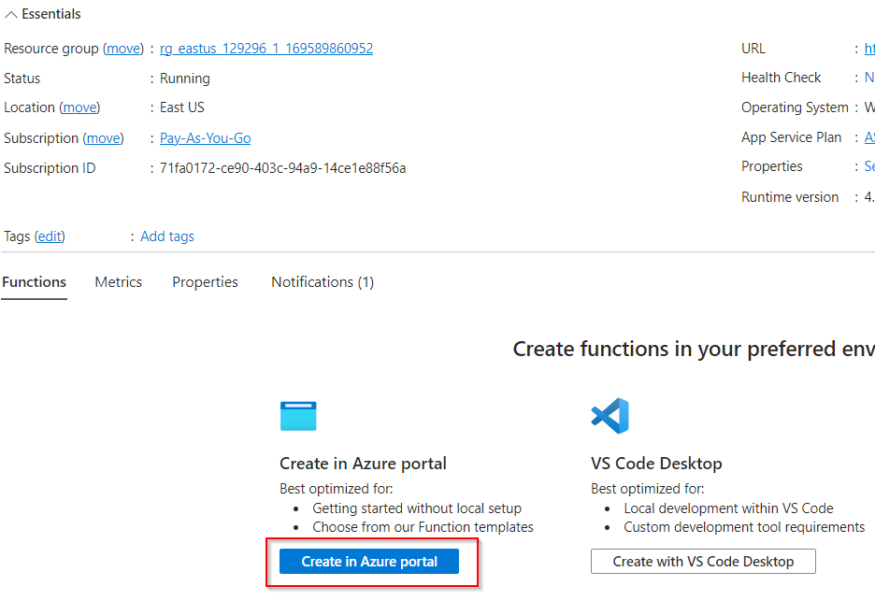

1. Click on **+ Create** button on the top and select the **HTTP trigger** box.

* **Note:** HTTP Trigger is a default readymade function that will be run whenever it receives an HTTP request, responding based on data in the body or query string. You can build you own function.

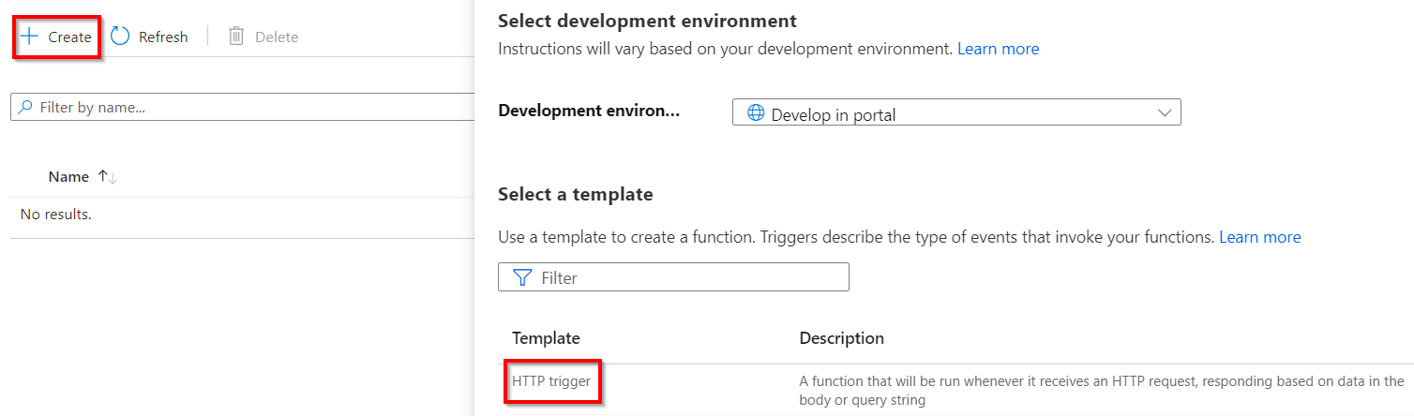

1. Scroll down and enter **WhizlabFunction** in the **New Function** name field and click on **Create**.

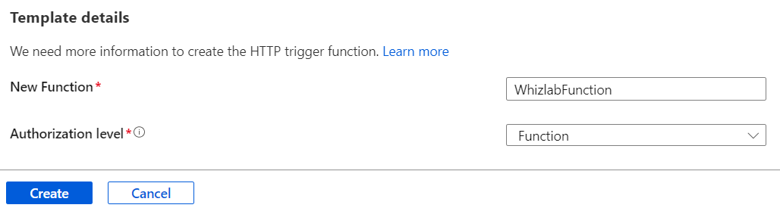

## ****Task 5: Test the Azure Function****

1. Select **Code + Test** on the left of the browser page to open the test panel.

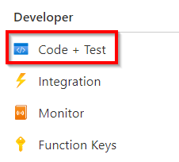

1. Click the **Test/Run** button on the top and then click on **Run** button.

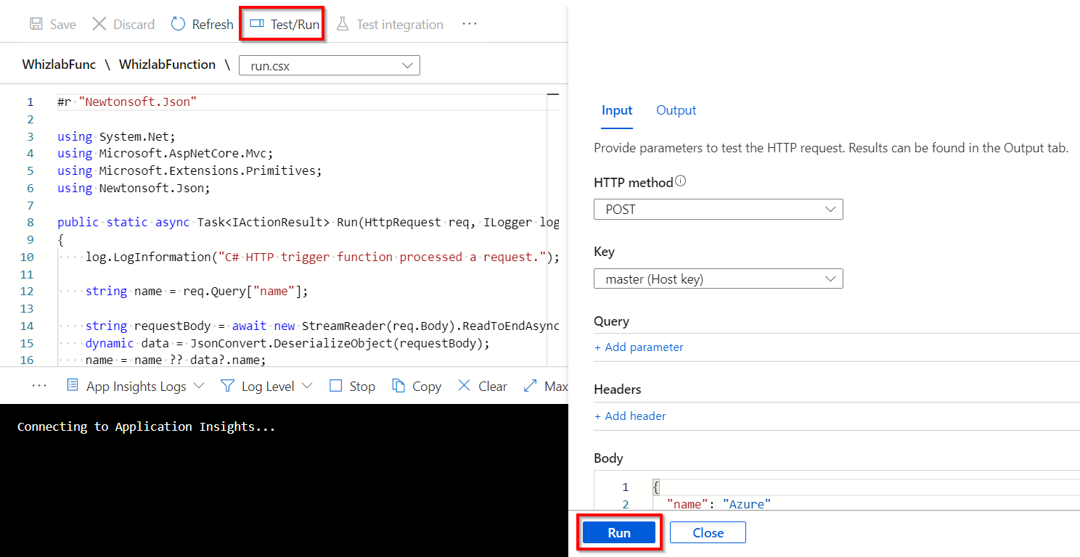

Verify the reception of a Status 200 OK message and a **Hello, Azure. This HTTP triggered function executed successfully** message in the Output panel.

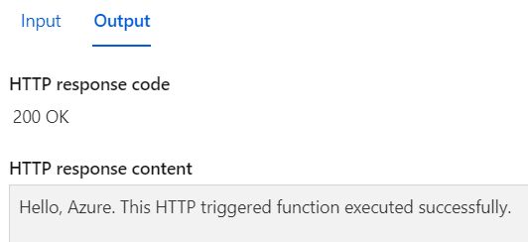

## ****Do You Know?****

**Azure Functions allow you to run your code in the cloud without worrying about managing servers, making it easier and more cost-effective to build and deploy applications. It's like having a virtual team of workers who automatically respond to events and perform tasks for you.**